Dissecting lungs
The purpose of this activity is:
- to find out about the structure of the lungs
- to find out how our lungs move as we breathe
- to relate the structure of the lungs to how they work when we breathe

Procedure
SAFETY:
- Wear eye protection whenever there is a risk to the eyes, for example, when changing scalpel blades, cutting cartilage or if the dissection material has been preserved.
- Take care with sharp dissecting tools and report any cuts to your teacher.
- Do not breathe directly into the lungs.
- At the end of the practical, disinfect the work area and wash your hands thoroughly using soap and hot water.

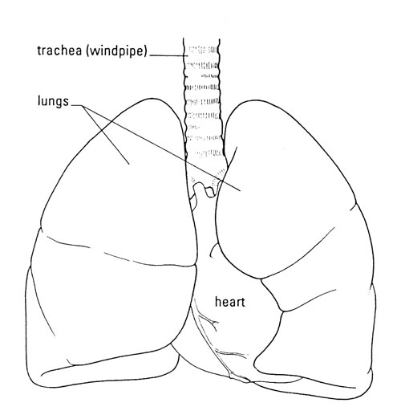
If you prefer not to work with the animal lungs your teacher has provided, you could research the lungs using books, models, or the internet. You could search for more information in this way after the practical.

Investigation
- Describe the look, feel and colour of the lungs.
- Identify the trachea and explore the texture of its wall.
- Explore the tubes that enter the lungs and see how they divide.
- If the heart is still attached, identify the main blood vessels leaving and entering the lungs. If not, try to identify large blood vessels anyway.
- Identify any membrane surrounding the lungs.
- Inflate the lungs (following your teacher’s instructions) and observe how they behave.
- Cut a piece of lung tissue and observe the cut surface and how the tissue behaves when you drop it into water.

QUESTIONS
- What structure makes the windpipe stay open, but able to bend?

- Are the lungs hollow bags or spongy? What does the lung tissue look like where you cut into it? What happens when you put this tissue into water?

- What are the lungs like when full of air? Do you have to squeeze them to push the air out again?

- In a living animal, what body movements draw air into the lungs?

- In a living animal, what body movements force air from the lungs?
ANSWERS
- Horseshoe-shaped rings of cartilage make the windpipe stay open, but able to bend.

- The lung tissue is spongy. When you cut into it you can see that it is permeated with air-filled tubes and blood vessels. A small piece will float in water.

- When full of air, the lungs expand but are still soft to the touch. If left to rest, some of the air comes out as the lung tissue relaxes down

- In a living animal, the lungs are surrounded by a pleural membrane that keep the outside surface in contact with the inner surface of the rib cage. The diaphragm (muscle at the bottom of the thorax) contracts and flattens, and the ribcage moves upwards and outwards. Both of these movements increase the volume of the ribcage, reducing the air pressure and so air is drawn into the lungs to equalise the pressure.

- In a living animal, the diaphragm relaxes and domes up into the bottom of the thorax, and the ribcage moves down and in. Both these movements reduce the volume of the ribcage, increasing the air pressure and forcing air out of the lungs to equalise the pressure.

